**LocMetrics for SLOC**

**Apache Commons Math**:

Version: 3.6 – Defect Density = 13/208840 = 0.00006225

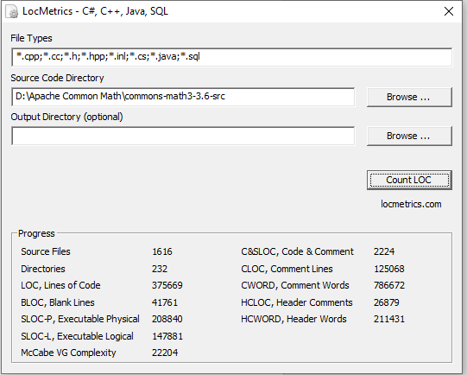

Version: 3.5 – Defect density = 38/196551 = 0.0000193

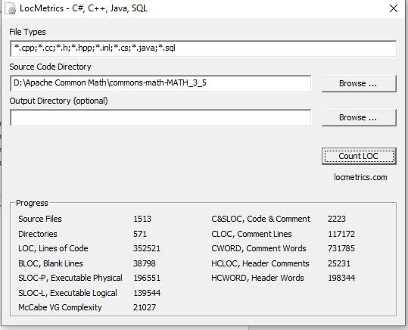

Version: 3.4 – Defect Density = 10/195595 = 0.0000513

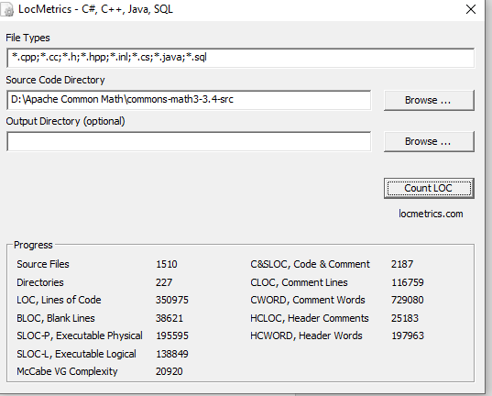

Version: 3.3 – Defect Density = 36 /189511 = 0.000189

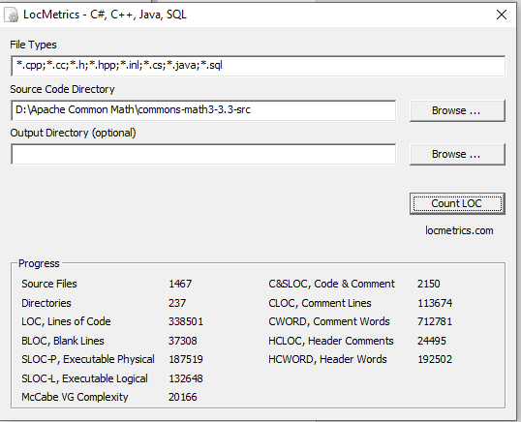

Version: 3.2 – Defect Density = 38/162818 = 0.000233

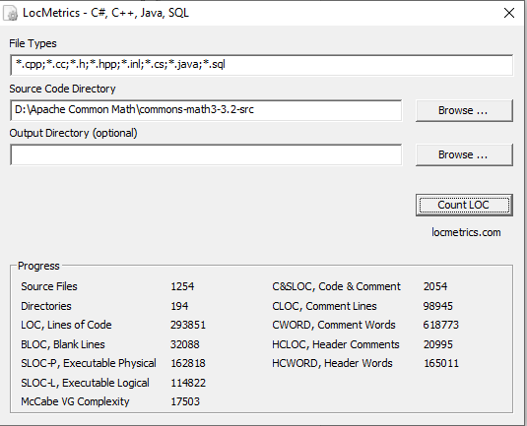

**Apache Commons Lang**:

Version: 3.9- Defect Density = 3/75643 = 0.0000396

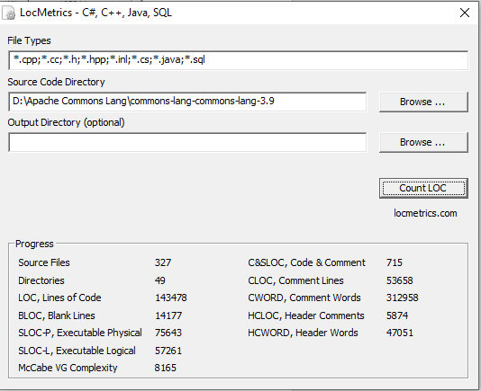

Version: 3.8- Defect Density = 4/78050 = 0.00005125

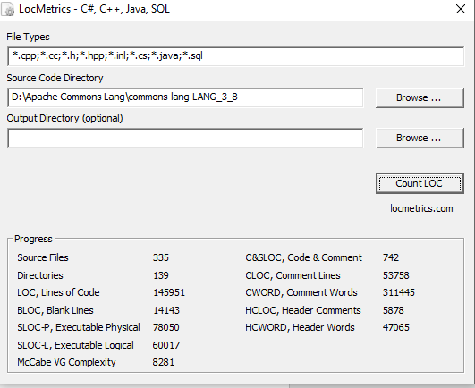

Version: 3.7- Defect Density = 16/75958 = 0.0002106

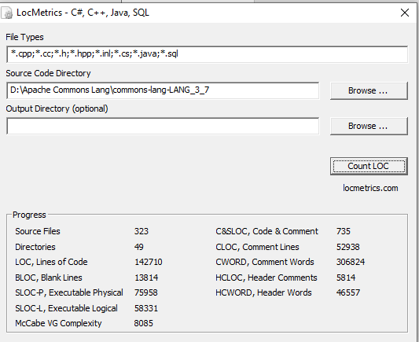

Version: 3.6- Defect Density = 13/75440 = 0.0001723

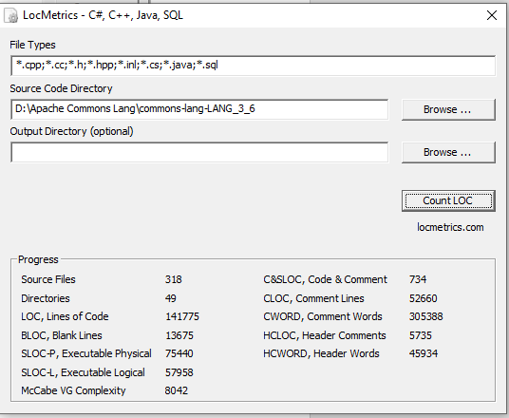

Version: 3.5- Defect Density = 33/72522 = 0.0004550

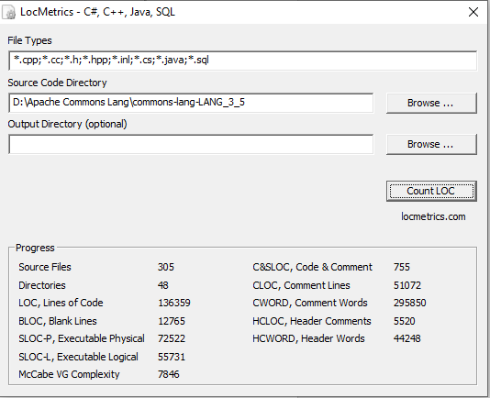

**Apache Commons Dbutils**:

Version: 1.7-Defect Density = 4/6864 = 0.000582

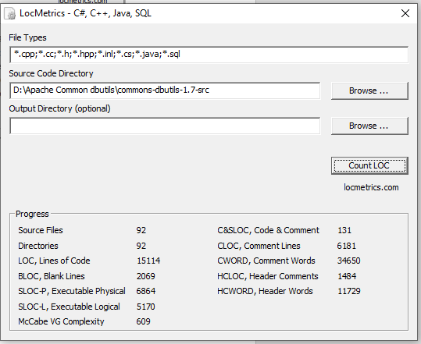

Version: 1.6-Defect Density = 5/5380 = 0.000929

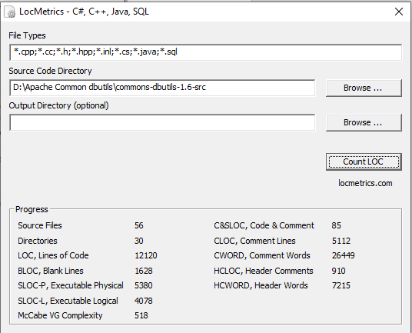

Version: 1.5-Defect Density = 8/4269 = 0.001873

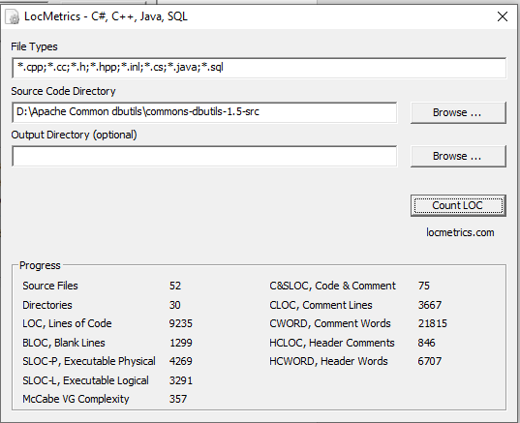

Version: 1.4-Defect Density = 2/3886 = 0.000514

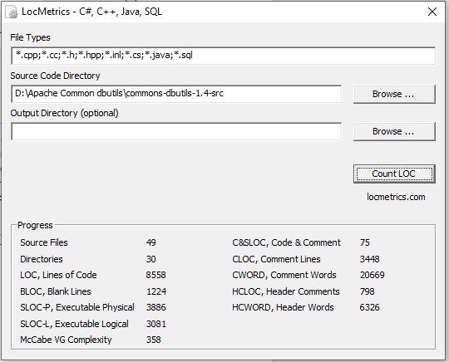

Version: 1.3-Defect Density = 8/3042 = 0.002629

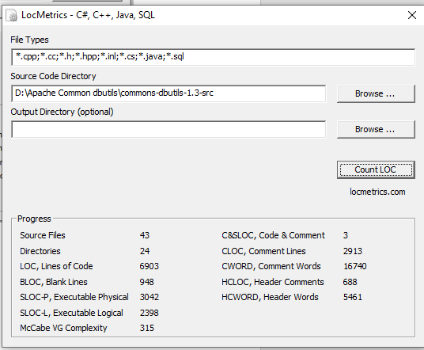

**Apache Commons Collection4**:

Version: 4.3- Defect Density = 1/62869 = 0.0000159

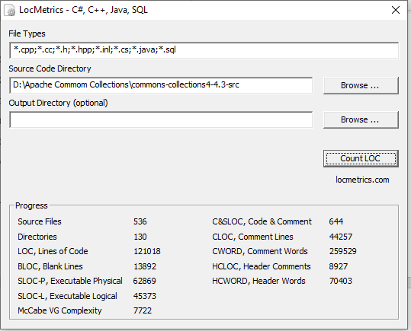

Version: 4.1- Defect Density = 16/60733 = 0.0002634

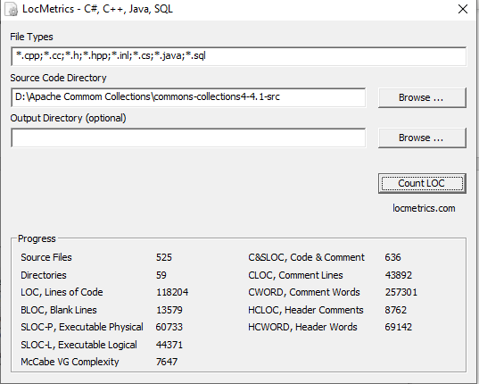

Version: 4.0- Defect Density = 37/51622 = 0.0007167

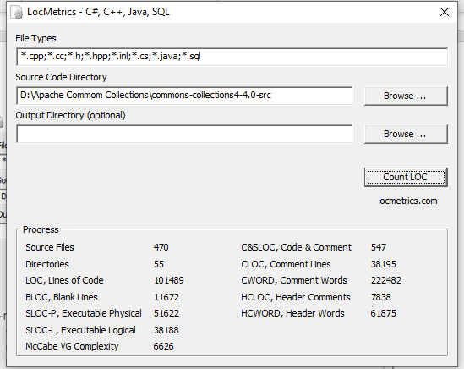

Version: 3.2- Defect Density = 59/55398 = 0.00106502

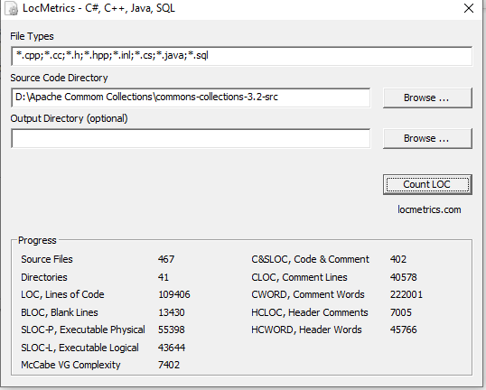

Version: 3.1- Defect Density = 49/51126 = 0.0009584

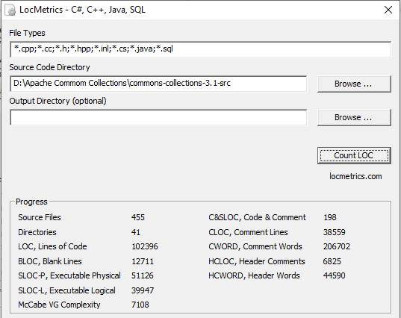

JfreeChart

Version: 1.0.15 defect density = 12/134119 = 0.00008947